*Master-Thesis*

*/*

*Masterarbeit*

**A study on the modeling of the distribution automation systems using Petri Nets**

/

**Eine Untersuchung zur Modellierung der Verteilnetzautomationssysteme mit Petri Netz**

*Huiyuan Xiao*

*Studienrichtung:*

Elektrotechnik und Informationstechnik

Professor: Prof. Antonello Monti

Supervisor : Abhinav Sadu

Aachen, den_____________ __________________________

Der 1. Prüfer

Aachen, den_____________ __________________________

Der Vorsitzende des Prüfungsausschusses

**Table of Contents**

1. Introduction 7

1.1. Motivation 7

1.2. Structure of Work 8

2. IDE4L project 9

2.1. Overview 9

2.2. IDE4L project automation concept and architecture 10

2.3. The major Use Cases 13

3. Petri Net 16

3.1. Origin and Development of Petri Net 16

3.2. Basics of Petri Net 16

3.2.1. Definition of Petri net 16

3.2.2. Structure of Petri Net 17

3.2.3. Mathematic representation 17

3.2.4. Operation rules of Petri Net 18

3.2.5. Property of Petri Net 19

3.2.6. Basic logic connections in Petri Net 20

4. Software platforms for Petri Net 22

4.1. Overview 22

4.2. TIMENET 4.0 23

4.3. ORIS 24

4.4. PIPE 25

4.5. Summary 25

5. Modeling of IDE4L for survivability evaluation using SCPN 26

5.1. MVPC 27

5.2. MVRTM 28

5.3. MVSE 29

5.4. MVSF 30

5.5. NDU 31

5.6. CCPC 32

5.7. Whole system 33

5.8. Theoretical basis behind qualitative analysis results 37

6. Modeling of IDE4L for dependability evaluation using STPN 38

6.1. IDE4L automation frame 38

6.2. Mathematical basis 40

6.3. Centralized automation vs. IDE4L 44

6.4. Approaches to improve distribution automation system dependability 45

6.5. Summary 49

7. Conclusions 50

8. Bibliography 51

9. Appendix 53

**List of Figures**

Fig.1 An overview of the IDE4L automation solution [1] 9

Fig.2 Interoperability layers of IDE4L [5] 11

Fig.3 Comparison between centralized and IDE4L approach [2] 12

Fig.4 IDE4L architecture [3] 12

Fig.5 Implementation of Substation Automation Unit [4] 13

Fig.6 HLUCs schematic [5] 14

Fig.7 A simple Petri Net 17

Fig.8 Basic logic connections represented by Petri Net 20

Fig.9 A sample screen shot of the interface [8] 23

Fig.10 ORIS tool [9] 24

Fig.11 PIPE interface 25

Fig.12 IDE4L overall automation architecture mapped on Smart Grid Plane [5] 26

After weighing the realization of the main functions and the simplicity of the diagram: 27

Fig.13 Simple PN of Medium Voltage Network Power Control (MVPC) 27

Fig.14 Scenarios-oriented PN of Medium Voltage Network Real Time Monitoring (MVRTM) 28

Fig.15 Simple PN of Medium Voltage Network Real Time Monitoring (MVRTM) 29

Fig.16 Simple PN of Real-Time Medium Voltage Network State Estimation (MVSE) 29

Fig.17 Simple PN of Medium Voltage Network State Forecasting (MVSF) 30

Fig.18 Simple PN of Network Description Update (NDU) 31

Fig.19 Simple PN of Control Centre Power Control (CCPC) 32

Fig.20 Scenarios-oriented PN of the whole system 33

Fig.21 Congregation PN of the whole system 34

Fig.22 PIPE simulation results 36

Fig.23. The system model of smart grid.10] 38

Fig.24. Frame in IDE4L [5] 39

Fig.25 IDE4L architecture STPN 44

Fig.26 Centralized automation (CA) architecture STPN 44

Fig.27 Separate single IED into control and monitoring IEDs 45

Fig.28 PSAU migration 46

Fig.29 PSAU migration 46

Fig.30 Separate single IED into control and monitoring IEDs while PSAU migration 47

Fig.31 DMS backup-strategy 47

Fig.32 Bad/Missing data detection/correction 48

Fig.33 PSAU backup-strategy 49

**List of Tables**

Table 1: IDE4L PUCs grouped by HLUCs and Clusters [5] 15

Table 2: Petri Nets tools comparison [7] 22

Table 3: Average tokens sorted descending 36

Table 4:Failure results 42

Table 5: Detailed failure probability of each use case 43

Table 6:The Firing Rates of Transitions 43

Table 7: CA vs. IDE4L 45

Table 8: IED separation 45

Table 9: PSAU migration 46

Table 10: Separate single IED into control and monitoring IEDs while PSAU migration 47

Table 11: DMS backup-strategy 48

Table 12: Bad/Missing data detection/correction 48

Table 13: PSAU backup-strategy 49

1. Introduction
   1. Motivation

With the higher penetration of distributed energy resources (DERs) and increase of the complexity due to interaction of huge number of actors in smart grid, Distribution Automation (DA) is needed at distribution level to enhance efficiency, reliability and quality of electric service. Distribution automation system is a complete stream of technologies for power utilities to achieve remote monitoring, coordination and real-time flexible allocation of distributed units, which includes substation automation, feeder automation and customer automation. Hierarchical and distributed control approach needs to be applied in DA, which introduces the concept of Substation automation, the function of merging information and coordination decisions is realized at substations. How to abstract distribution automation system as an accurate and observable model and then complete the performance analysis plays a significant role for the further grid upgrade. The reliability and effectiveness of the smart grid are closely related to the automation level of the distribution network. In order to ensure the normal operation of this complex system, accurate modeling and analysis of system architecture is critical to avoid the lack of controllability.

As Petri net theory has a significant advantage in the analysis of complex discrete control systems, it has been applied effectively in many fields. At the same time, Petri net integrates intuitive representation of graphics and rigorous mathematical derivation and has a certain of applications in the field of power systems, including power system failure analysis and so on. But so far, there is no precedent in modeling of the distribution automation power system using Petri Net theory.

This paper present an investigation of the modeling of the distribution automation systems IDE4L (the next generation active distribution power system) and traditional centralized automation system using Petri Net theory, through which can achieve a concise expression of the system architecture and complete the follow-up analysis and comparison of survivability and dependability. Note that the present paper addresses the qualitative impact of a single component failure on the overall system, rather than the specific possibility of quantifying the event. Then introducing two metrics: reliability and availability to evaluate the system capability and the effect of protection approaches to avoid failures. A comparison between IDE4L architecture and centralized architecture prove the advantages and necessity of grid upgrade.

* 1. Structure of Work

The thesis is divided into seven chapters including the introduction. The second section introduce the IDE4L project, the system this paper try to focus and model. Section 3 is a short overview of Petri net theory. Section 4 exemplifies and compares several major simulation tools for Petri net. Section 5 models IDE4L architecture for survivability evaluation using SCPN while section 6 modeling IDE4L architecture for dependability evaluation using STPN. Section 6 also completes a performance comparison and puts forward several protection approaches. Finally the conclusions and the future extensions of the work are documented in the seventh chapter.

1. IDE4L project
   1. Overview

The IDE4L (Ideal Grid for All) project is funded by the 7th Framework Program (FP7) of the European Commission (Grant agreement no: 608860) from September 2013 to August 2016, with a budget of €8M.

The penetration of various renewable energy sources has caused a huge impact on the existing power network. The aim of the project is to integrate distributed energy equipment in recent years to reduce carbon dioxide emissions, reduce network losses and save energy. Through active distribution of networks, automated architecture and active network management, IDE4L hopes to improve the visibility of the distributed resources of operators and aggregators by improving network control and monitoring, making efficient use of existing networks, then can design a future grid that can provide clean and reliable energy, while ensuring the continuity and stability of the electricity supply

As shown in Figure.1, IDE4L builds the entire distribution network automation, IT systems and active network management functions. Focusing on fault location, isolation and supply restoration, congestion management, and the interaction between distribution and transmission network companies. The project also focuses on the large-scale integration of distributed resources to design and operate intelligent solutions for distribution networks to ensure continuity and quality of power supply.



Fig.1 An overview of the IDE4L automation solution [1]

As IDE4L is the future automation architecture for distribution grids of European including a large number of next-generation solutions for monitoring, control and business problem with great practical value, we choose it as the analysis target in present paper. At present, the project has completed the design, development, prototype design and testing phase in laboratory, began to carry out the corresponding industrial inputs.

* 1. IDE4L project automation concept and architecture

With the increasing demand from electricity grid and customers, power utilities must use new technologies and services to improve power quality, system performance reliability and user experiences. For a new generation of upgraded power grids, distribution automation has important significance for overall operations and management. IDE4L is the highly automated system for these requirements. It has a more flexible electrical system architecture for easy integration of new intelligent electronic equipment (IED), renewable energy (including photovoltaic and wind farms); with an open communication network and information exchange model to protect the data exchange and two-way communication between control center and the user terminal; Real-time monitoring of grid status and implementation of predictions to continuously optimize system performance.

The automation architecture development of IDE4L is supported by two main concepts, namely the Smart Grid Architecture Model (SGAM) framework (Fig.2) and the Use Case (UC) Methodology. Existing standards (especially IEC 61850 series and CIM) helps the building of SGAM framework, while supporting the interaction of various applications. The relationship between them is that SGAM framework defines a general description (a unified template) to use cases to achieve the standardization of physical composition and logical implementation. Use Case (UC) Methodology gifts IDE4L the following characteristics:

1. Hierarchical and decentralized automation architecture；

2. Modular distributed processing;

3. Reusable procedures.



Fig.2 Interoperability layers of IDE4L [5]

Figure 3 presents the comparison between centralized and IDE4L approach. More details can be found in figure 4, as the same process (e.g. power control (PC)) can be implemented at LV level (Secondary Substation Automation Units (SSAU)), MV level (Primary Substation Automation Units(PSAU)) and control center level(Data management system(DMS)) in a coordinated manner. This structure diagram introduces the way to operatively develop IDE4L´s architecture. Firstly, the overall structure is divided into several blocks — control center, MV/LV substation, customer center and so on. Then goes into further partition and definitions of each physical device (e.g. PSAU in MV substation). Note that although not explicitly shown in this diagram, each physical device also includes different logical components (e.g. PSAU.MMS, PSAU.PC PSAU.SE) that correspond to different logical functions, while communicating with each other.

Taking advantage of these modular functions, the entire structure supports the normal operation of the project and the recovery after the possible attack.



Fig.3 Comparison between centralized and IDE4L approach [2]



Fig.4 IDE4L architecture [3]

SAU is the core implementation component of IDE4L architecture. We can associate the architecture overview in Figure 1 and the inner details of SAU presents in Figure 5.Through the interface protocol, SAU can adapt to both local and remote requirements, and easily combine with the existing equipment, complete the corresponding control and monitoring tasks. This greatly reduces the cost of grid upgrades.



Fig.5 Implementation of Substation Automation Unit [4]

* 1. The major Use Cases

IDE4L projects contains a total of 26 UCs, which can main divided into mainly three clusters according to the different functions:

* Monitoring
* Control

• Business

By consulting the project manual provided by official website, the actor, function and data flow direction of each UC can be conveniently achieved. These files are the basic information for the following drawing of petri nets.Figure.6 gives HLUCs schematic with synthetic representation of information exchange, use cases of three different clusters are framed by three different colors.



Fig.6 HLUCs schematic [5]

Table 1 lists all the 9 HLUCs (A High level use case (HLUC) describes a general requirement, idea or concept independently from a specific architectural solution [5]) and 26 PUCs (the IDE4L Primary use case(PUC) are described according the following scheme: a complete description including scope and goal of the UC follows a step analysis, and the use case diagram is given where actors and functions are mapped into the Smart Grid Plane[5])) in IDE4L architecture. As the purpose of this paper is to study the survivability of the grid under abnormal states, mainly focus on the control and monitoring use cases in medium voltage level.

The next chapters will discuss 6 HLUCs that have most significant impact on the grid operation (MVPC, MVRTM, MVSE, MVSF, NDU, CCPC). Following we first introduce the basic definitions of Petri nets and then give a description of these use cases one by one and then give an idea of how to build them into one main Petri net.

****Table 1: IDE4L PUCs grouped by HLUCs and Clusters [5]

1. Petri Net
   1. Origin and Development of Petri Net

The Petri net theory was first fully introduced by German [mathematician](https://en.wikipedia.org/wiki/Mathematician) and [computer scientist](https://en.wikipedia.org/wiki/Computer_scientist) Carl A. Petrie in his doctoral thesis “*Kommunikation mit Automaten* (communication with automata)” in 1962 to describe the causal relationship between the computer system events.

Early Petri nets were mainly used in the field of computer and information processing. With the discovery of the advantages of Petri nets in parallel and distributed computing, researchers with engineering backgrounds in the 1980s tried to use the Petri nets in engineering systems, especially in complex automated manufacturing systems and workflow management systems. For more than 40 years, with the continuous enrichment upgrades of Petri nets´ own theory, as well as interdisciplinary collaborative research, it has become a useful research and analysis tool in the fields of computer, automation, communication, transportation, electric power and electronics, service and manufacturing.

Back to the field of power systems related to the subject of this paper, Petri net theory has also been applied to many other hot topics such as failure location identification, concurrency and collision workflow modeling, power system reconfiguration, power system security evaluation, smart grid interaction. The feasibility of this thesis is based on the research of these studies.

* 1. Basics of Petri Net
     1. Definition of Petri net

Petri net is a visual graphical mathematical modeling language to model static structure and dynamic change of Discrete Event Dynamic System (DEDS).It is a structured description tool which is able to represent synchrony, synchronization, and parallel logical relationships.

Petri net has both rigorous mathematical expression and intuitive graphical representation. As a graphical tool, Petri net can clearly represent concurrent, asynchronous, conflict, distributed, parallel and other behaviors. As a mathematical tool, it can build a model by state equations to perform reliable mathematical analysis. As a result, it can describe the conflict and concurrency processes while clearly representing the static and transient state of the system.

* + 1. Structure of Petri Net

Petri net includes elements such as location, transition, and arc. The input arc connection begins at the end of the position, and the output arc ends at a position from the transition. Of course, other types of arcs, such as suppression arcs, appear in more complex systems. The traditional Petri net is a simple process model consisting of two nodes: the place and the transition, the directional arc, and the token and other elements.

The classic Petri net is a simple process model consisting of elements such as places, transitions, directed arcs, and tokens (Figure 6).



Fig.7 A simple Petri Net

* Place: a circle (P0, P1, P2)
* Transition: a rectangle (T0, T2)
* Arc: a tangential arc between the place and the transition
* Token: a dynamic object in the place (represented by a dot in the place P) that can be moved from one place to another

Note：

* The arc is directional
* There is no arc between two places or transitions
* The library can have any number of tokens
* There are two possible changes to be allowed, but only one change can occur at a time
  + 1. Mathematic representation

Definition：The structure of a PN is a directed graph described by 4 elements:

PN = {P, T, I, O}

Here:

P = {P1, ... , Pn} is a finite set of the places, n> 0 is the number of the places;

T = {T1, ... , Tm} is a finite set of transitions, m> 0 is the number of the transitions, P ∩ T = ⊙ (empty set);

I: P × T → N is an input function that defines the set of repetitions or weights of the directed arc from P to T where N = {0,1 ...} is a nonnegative integer set ;

O: T × P → N is an output function that defines the set of repetitions or weights of the directed arc from T to P.

Further defined a marked Petri with 6 elements:

PN = {P, T, F, K, W, M0}

among them:

P = {P1, ..., Pn} is a finite set of the places;

T = {T1, T2, ... Tm,} is a finite set of transitions,

F =(P × T) ∪ (T × P), arc set;

K: P → N +, the capacity function of the places, K (P) = ω denotes that the capacity of P is infinite, N + = {1,2, …};

W: F → N +, weighting function of arc;

M0: P → N, initial marking, request: P ∩ T =, P ∪ T ≠ ф;

M: P → N, N = {0,1,2, ...}, the marking of the PN

* + 1. Operation rules of Petri Net

In the PN, we use one transition T to represent an event, and the enabling with the transition indicates that the event can happen if the prerequisite is satisfied. We also use the input place of T (e.g.P0 for T0 in fig.6) to represent the preconditions for the occurrence of the event, and the number above the arc is the requirements of the input function. And implementation times of the local state is represented by the number of tokens contained in the place.

If all the input places of a transition have at least one token, the transition is enabled. When a transition is enabled, the transition can fire, then the token of the input place is consumed, and the token is generated for the output place.

* + 1. Property of Petri Net

1. Reachability

The system can achieve the specified state after several transitions. State M1 is reachable from state M0 means that there is an enabled transition sequence σ to run the initial state M0 into M1.

The reachability is used to describe two problems of manufacturing systems.

1) If the system is running according to a certain trajectory (a certain transition sequence), whether it can achieve a specific state or never achieve an undesirable state

2) In order to reach a certain state, how to determine the system's trajectory.

2. Boundedness and safety

The number of tokens does not exceed a finite integer k in each place in a Petri net, namely p ∈ P, M (p) ≤ k, then this Petri net is called k-bounded, when k = 1 the system is safe.

Boundedness reflects the need of resource variables during system operation. In theoretical analysis, the capacity of a place can often be assumed as infinite. However, in actual system design, it is necessary to ensure the number of tokens in each place is less than the capacity of the place in any state to avoid overflow phenomenon.

3. Liveness

Liveness indicates that the system can operate normally, that is, no deadlock in the system. For a transition T, if there is a transition sequence σ，the firing of this transition sequence pushes the transition T to be enabled, then the transition is said to be active. If all the transitions of a PN are live, the PN is live.

4. Reversibility and home state

Reversibility represents the recoverability of the system operation, which means the system can be returned from the current state to the initial state.

If M '∈ R(M), any M' is reachable from M0, M0 is called the home state. This situation corresponds to an actual physical system that can be returned from a current state to a specified state, not an initial state.

* + 1. Basic logic connections in Petri Net



Fig.8 Basic logic connections represented by Petri Net

* 1. Extensions of Petri Net

Petri net is fundamentally different from other system modeling methods with its own distinct characteristics.

1.The model semantics is very standardized with strong expression ability, so Petri net can fully support the basic process logic in reality (shown in Fig.7).

2.The model is state-based, very intuitive. Many modeling methods (such as GRASP, PERT) are event-based and lack a clear representation of system state. Petri net can dynamically modify the process instance, so the modeling process has more flexibility features.

3.Strong analytical skills. Petri net is based on rigorous mathematicians and have powerful analytical techniques and tools to analyze various characteristics of the model, such as boundedness (safety), liveness invariant. It can also calculate various performance indicators, such as response time, waiting time, resource sharing and so on. These analytical techniques can also be used to verify some of the basic requirements and properties of the process from both theoretical and simulation aspects. Through the analysis, the model can also be optimized to achieve the best performance.

However, there are still some limitations of classical Petri nets:

1.Model is easy to become very large.

2.The model can not reflect the time characteristics.

3.Does not support the construction of large-scale models, such as top-down or bottom-up.

Therefore, scientists are still trying to expand Petri net in both vertical and horizontal direction:

Vertical extension is from the basic P/T PN to advanced PN (such as predicate / transition PN, colored PN). Horizontal extension is from traditional Petri nets to timed Petri nets and stochastic Petri nets. As IDE4L system has Multi-event concurrency feature, Stochastic Color Petri Net and Stochastic Time Petri Net are good choices for the follow-up modeling.

Stochastic Color Petri Net (SCPN) is an advanced petri net, especially useful for the description of complex random discrete event systems, so it is suitable for the analysis of the IDE4L function layer(Fig.8) in section 5 .Its main difference from standard Petri net is that the tokens in SCPN may have many defined attributes. Thus, unlike the single token attribute in standard Petri net, SCPN can define and identify different tokens in the same place, thus completing a more complex logical network architecture with the ability for building hierarchical definitions. Stochastic Time Petri Net (STPN) means the transition may have time delay，which is suitable for the logical analysis of the IDE4L communication layer in section 6.

1. Software platforms for Petri Net



Table 2: Petri Nets tools comparison [7]

* 1. Overview

In recent years, due to the advantages of Petri nets in the graphical visualization of system model, Petri net is widely used in many fields. Thus the drawing, evaluation and analysis of petri net also attracted a lot of attention. There are many types of software tools have different focus. In order to choose the most suitable one for drawing and analysis of IDE4L system, this section will introduce, analysis and compare the current mainstream of several major Petri Nets tools.

<http://www.informatik.uni-hamburg.de/TGI/PetriNets/tools/quick.html> is the Petri net tool summary list. Unfortunately, many of these tools are no longer updated or available due to installation problems, lack of functionality, lack of qualitative and quantitative analysis capabilities. With further collected information, Table 2 is a review of the major Petri Nets tools. Considering the open source and cost issues, this paper focuses on three new emerging software in recent years: TimeNet, ORIS and PIPE. The following part will first introduce the foundation of these three tools, and then combine with IDE4L´s modeling requirements to compare their different characteristics. Different software has its unique advantage and disadvantage in the drawing, simulation, and analysis process. The ultimate goal is to give a use reference.

* 1. TIMENET 4.0

TimeNET (**Time**d **N**et **E**valuation **T**ool) is a graphical and interactive software tool for the modeling and analysis of stochastic Petri nets with non-exponentially distributed firings (stochastic Petri nets (SPNs) and stochastic colored Petri nets (SCPNs)). The newest version takes the advantages of:

* The graphical user interface can be easily expanded
* Integrated steady-state and transient analysis of discrete time deterministic and stochastic Petri nets
* Graphically simulation results of SCPN
* Modular modeling, simulation, analysis and results parts can run on different computers, high portability

****Fig.9 a sample screen shot of the interface [8]

* 1. ORIS



Fig.10 ORIS tool [9]

ORIS is a modeling and analysis tool, which supports various types of timed expansion Petri Nets. It can be achieve the qualitative and quantitative assessment of corresponding PN. Key features includes：

* Graphic Petri Net Editor
* Non-deterministic Analysis of Time Petri Nets
* Transient Analysis of Non-Markov Random Petri Nets

One more advantage is the automatic alignment and shape adjustment, which makes the whole petri net more neat and beautiful.

* 1. PIPE

PIPE stands for Platform Independent Petri Net Editor, which is an open-source toolkit for creation, simulation and analysis of Petri nets including Generalized Stochastic Petri nets.

The main advantage of PIPE is its modular functions; users can develop their own analysis module to meet differentiated demands. And PIPE is functional-friendly to drawing and analysis of color Petri Net, which makes PIPE the best choice for modeling of IDE4L in function layer.



Fig.11 PIPE interface

* 1. Summary

We cannot simply determine which software is more powerful; each of these three softwares has its own advantages in different directions. The different focusing layers of IDE4L project and different analysis needs of use cases should be combined with the corresponding tool characteristics and personal preferences to complete the tool selection. PIPE is mainly used in section 5 for function layer (SCPN) due to its convenience in token attributes definition, and ORIS is mainly used in section 6 due to its performance analysis functions for component layer (STPN).

1. Modeling of IDE4L for survivability evaluation using SCPN

Below (Fig.7) is the IDE4L overall automation architecture concept mapped on to the Smart Grid Plane. It can be seen that although the following figure shows the links between the various components, but the lines are chaotic, the logic is not clear, very detrimental for further analysis. But Petri net can solve these problems well.



Fig.12 IDE4L overall automation architecture mapped on Smart Grid Plane [5]

Following parts first assess the qualitative impact of a single component failure on the entire system. Due to the complexity of the system scenarios, we choose SCPN as basis model, and PIPE as a simulation tool. This section first models the automatic distribution network in function layer, the actors are indicated as places, the functions as transitions, the information flow as the directional arc, different information or data sources as different color tokens. Then evaluates the impact of physical components (actors) failure on overall system survivability through simulation.

* 1. MVPC

Medium Voltage Network Power Control (MVPC) demonstrates how MVPC interacts with other actors to optimize and control the power flow and to mitigate congestion in MV networks. To reach the above-mentioned goals, the MVPC requires interacting with the following actors.：

• Primary Substation Automation Unit Data Exchange Platform (PSAU.DXP) where PC reads all necessary inputs and writes changes of IED settings.

The actors updating necessary data in the PSAU.DXP to be further used by MVPC are as follows:

• Control Centre Topology Manager (DMS.TM)

• Primary Substation Unit Block OLTC’s of Transformers (PSAU.BOT)

• Primary Substation Automation Unit Power Control Offline Cost Parameter Update (PSAU.PCPU)

• Primary Substation Automation Unit State Estimation (PSAU.SE) and complete medium voltage network real-time monitoring use case providing necessary data to PSAU.SE

• Intelligent electronic devices (IEDs) located in the MV network where measurement data is received and control commands are sent

After weighing the realization of the main functions and the simplicity of the diagram: 

Fig.13 Simple PN of Medium Voltage Network Power Control (MVPC)

* 1. MVRTM

Medium Voltage Network Real Time Monitoring (MVRTM) addresses the MV level data collection and stores these measurements (mean values and PQ indexes), states and alarms in a unique repository – located in the Primary Substation – after managing some implementation issues, such as protocol conversion and writing of data into the PSAU.RDBMS (Relational Database Management System in primary substation automation unit).“Real-time” here means something in between 1 second and some minutes.

In this use case contains a variety of scenarios, the following gives two PNs for comparison ( Fig.14 and Fig.15)： 

Fig.14 Scenarios-oriented PN of Medium Voltage Network Real Time Monitoring (MVRTM)

 Fig.15 Simple PN of Medium Voltage Network Real Time Monitoring (MVRTM)

* 1. MVSE

Real-Time Medium Voltage Network State Estimation (MVSE) complete the combination of all available measurement information and the calculation of the most likely network state. The current time (t = 0) state is estimated by real-time data. Real-time PSAU.SE is a secondary function of PSAU.PC and other primary functions, depending on the needs of the primary function (on demand or periodically).



Fig.16 Simple PN of Real-Time Medium Voltage Network State Estimation (MVSE)

The input data includes real-time measurements of load, production and line flow, load estimates of unmeasured loads, and network topology. While output data includes the live node voltage, line current, and node power injection values describe the network status.

The operation of PSAU.SE is realized by intelligent devices located in primary substations or control centers.

* 1. MVSF

The main function of Medium Voltage Network State Forecasting (MVSF) is to predict MV network-related status. The implementation of the PSAU.SF algorithm relies on secondary substations, MV clients and distributed generation predictions.

PSAU.SF will run once every 10 minutes after PSAU.FC and provide allocation attributes for pre-predicted expectations.



Fig.17 Simple PN of Medium Voltage Network State Forecasting (MVSF)

* 1. NDU

Network Description Update (NDU) complete the real-time update of DMS primary database and primary database in utilities Control Center, including the description of the network topology, the asset list and its parameters, customer lists and related information.

 Fig.18 Simple PN of Network Description Update (NDU)

* 1. CCPC

Control Centre Power Control (CCPC) determines the next hour (day market or intraday market time frame) of the SME management network congestion management function through the network and market-related measures.



Fig.19 Simple PN of Control Centre Power Control (CCPC)

* 1. Whole system

Similar to MVRTM, the whole system contains a variety of scenarios, the following are given two PN comparison (Figure 14 and Figure 15)



Fig.20 Scenarios-oriented PN of the whole system



Fig.21 Congregation PN of the whole system

Above is the model of IDE4L architecture on the function layer, while place indicates function, transition indicates corresponding behavior. These PN diagrams allow us first intuitively find PSAU.RDBMS and PSAU.MMS are the cores of whole model, sort the impact of the corresponding function on the overall system's survivability then by numerical analysis through PIPE simulation function:

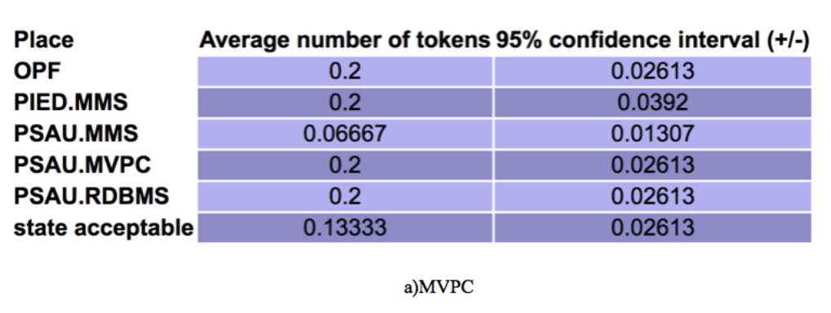

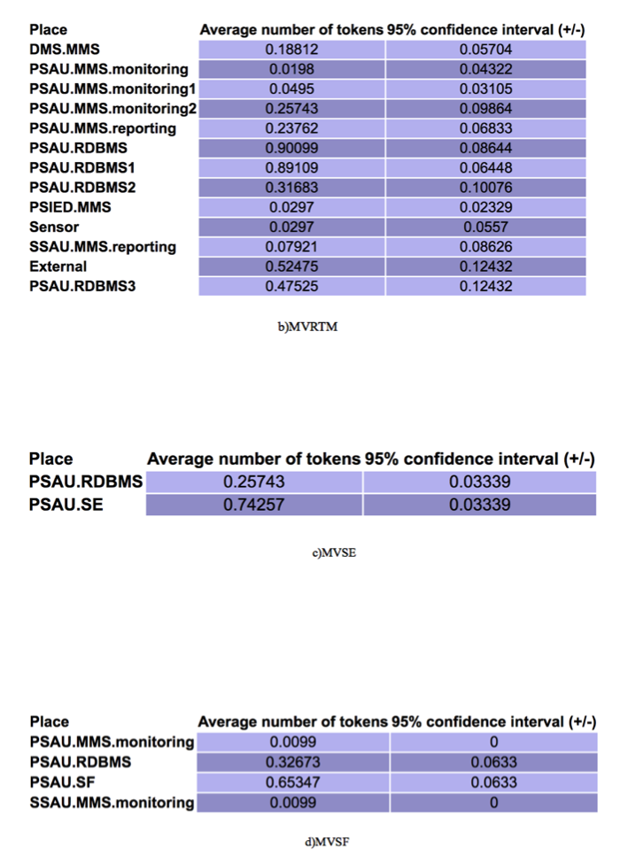

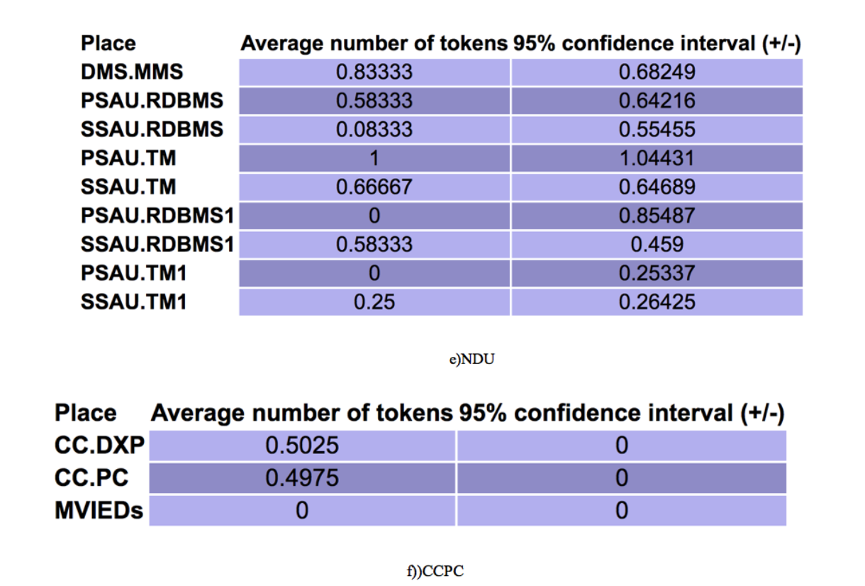

Fig.22 PIPE simulation results



Table 3: Average tokens sorted descending

As can be clearly seen from the above table, PSAU is the most important component for survivability in component level and in the function level PSAU.RDBMS has the greatest impact. Therefore, next section will pay more attention to PSAU network in the subsequent dependability analysis. Note that the analysis of other components cannot be ignored.

Aforementioned modeling method focus the data transfer in different scenarios of different use cases to address entire data chain. It shows the interdependencies between different component functions step by step. The advantage is that each transition is a specific event, easy to understand and find the details. The disadvantage is also obvious: PN is too complicated to carry out further calculations. So in the next section we will try to use logical chain to abstract PN.

* 1. Theoretical basis behind qualitative analysis results

For increasing grid resource actors, there are different control approaches:

1. Centralized automation (CA) architecture:

- Coordination takes place at the control center level, the distribution management system (DMS)

- Centralized high data risk, time consuming execution

2.IDE4L automation distribution architecture：

-Allocating the intelligence at each voltage level, PSAUs are responsible for the MV network and SSAUs address the need related to LV network

-Reducing the DMS computational and communication burden, while maintaining the possibility to coordinate the automation in a hierarchical way

-A proper coordination among the SAUs and with the DMS guarantees effective monitoring and control functionalities within shorter time frames than CA approaches and with higher efficiency than the fully distributed architectures.

1. Modeling of IDE4L for dependability evaluation using STPN
   1. IDE4L automation frame

This section attempts to abstract the main failure modes from complex application scenarios then model the failure chain using STPN. Stochastic Time Petri net is a type of timed Petri nets where transitions may occur (“fire”) after random time, including two types: timed transitions (drown as boxes) and immediate transitions (drown as bars). Generally transition delays are assumed to be exponentially distributed which ensure the convenient transformation from STPN to an equivalent Continuous-Time Markov Chain (CTMC). CTMC is an important prerequisite for following easy mathematical analysis. Using STPN model, we can evaluate the overall dependability from two metrics——the reliability and availability. Detailed probabilities derivation will be figured out in section 7 in both transient and steady state situation.



Fig.23. The system model of smart grid.10]

The purpose of this section is a perceptual knowledge of IDE4L architecture at the logical level(component layer).Through the combination the general model of the smart grid (Fig.23)and the IDE4L system(Fig.3), we mainly abstract the four physical components namely Sensor, IED, PSAU and DMS(SCADA).Then we separate them into two states : normal operating mode (on) and failing down mode (down).Here are 8 places corresponding to different states in STPN: Sensor_on, Sensor_down, IED_on, IED_down, PSAU_on, PSAU_down, DMS_on， DMS_down. Initially, each device is in the normal operating mode, which is denoted by one token in Sensor_on, IED_on, PSAU_on and DMS_on. But after suffering from diverse possible failure events (transitions firing), normal operating modes will transfer to failing down mode denoted by the place Sensor_down, IED_down, PSAU_down, DMS_down.

A failure event can influence the non-adjacent elements located on the information chain (in this section modeled with STPN) in a cross level, and this interaction is the difficulty and significance of following modeling. It must be noted here that we will ignore the details of the various failure events (actions), only concern about the results of these events, which led to failures. This makes it unnecessary for us to understand in detail the specific mechanism of each transition.



Fig.24. Frame in IDE4L [5]

* 1. Mathematical basis

1.reliability

Reliability is used to evaluate the capability to continuously provide services without failures. In detail, it can be defined as the probability that the control center networks work correctly during the period[0,t],where X is the continuous random variable of correct operation time for control center networks:

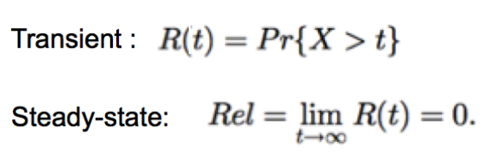

2.availability

Availability describes the readiness of correct services for some critical components:

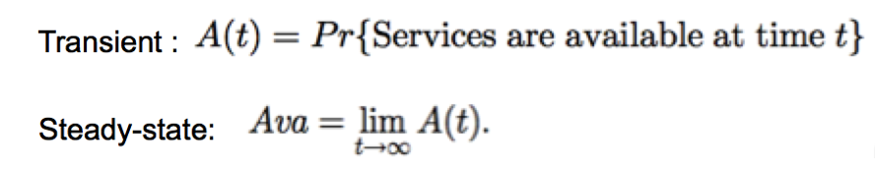

Calculation method of reliability and availability in both steady state and transient aspects involves two steps:

1.the analysis of the equivalent continuous time Markov chain

2.and the computation of reliability and availability.

As the theory in [12] has proved that k-bounded SPNs are isomorphic to CTMC due to the memoryless property of the exponentially distributed service time. It is easy to infer an association between SPNs’ markings with the CTMC’s states to achieve the isomorphism property [13].

Thus, there are two equivalent methods to compute the steady-state probability of CTMC:

(1)

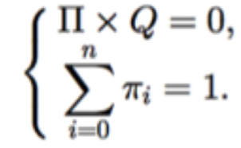

For further calculations, we first define the variables in the formula:

1.The infinitesimal generator Q=[qij], where qij(ij) indicates the transition rates from states Mi to Mj ,Mi to Mj, qij = 0 if Mj can not transform from Mi；

2.i is steady-state probability which can be obtained from these linear equations.

This method suitable for calculations on clusters

(2)

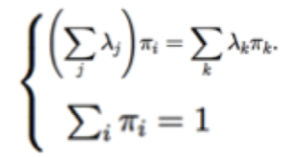

Similar to method 1, we first define the variables in the formula:

1.i is the Firing Rate of Transitions;

2.i is steady-state probability which can be obtained from these linear equations.

Transient probability in above two methods can be derived by：

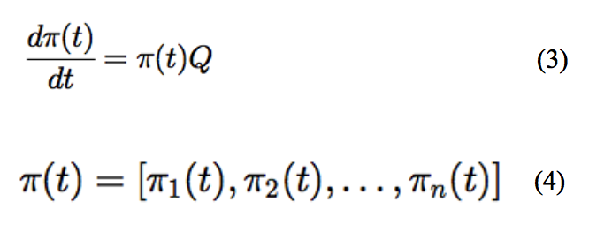

Specific mathematical calculations are very complex; fortunately there is already software to complete the calculation. With ORIS's own performance analysis tools, we can quickly obtain transient and steady-state analysis results both in data and graph.

The GSPN analysis is an analysis of the probabilities of being in a certain state at a certain moment in time, given that the process started from another given state. This analysis generates a matrix, with time as the first dimension and the possible arrival states, starting from the initial marking, as second dimension.

Combined with the mathematical theory in 6.2, the results of GSPN analysis is i(t).With i(t) and equation (3) we can compute the reliability and availability of each component using formulas (5) - (8):

 (5) ————- transient reliability

 (6) ————- steady-state reliability

 (7) ————- transient availability

 (8) ————- steady-state availability

 is the weight of each transition, for the sake of simplicity, all equal to 1.

In order to facilitate the subsequent comparison, we take the steady states probabilities i to represent the characteristics of these two metrics and indicate the dependability.

GSPN analysis can be performed on the various architectures modeled in section 6.3 and 6.4, after data processing and induction we can obtain the failure results including failure components numbers and failure probabilities in table 4:

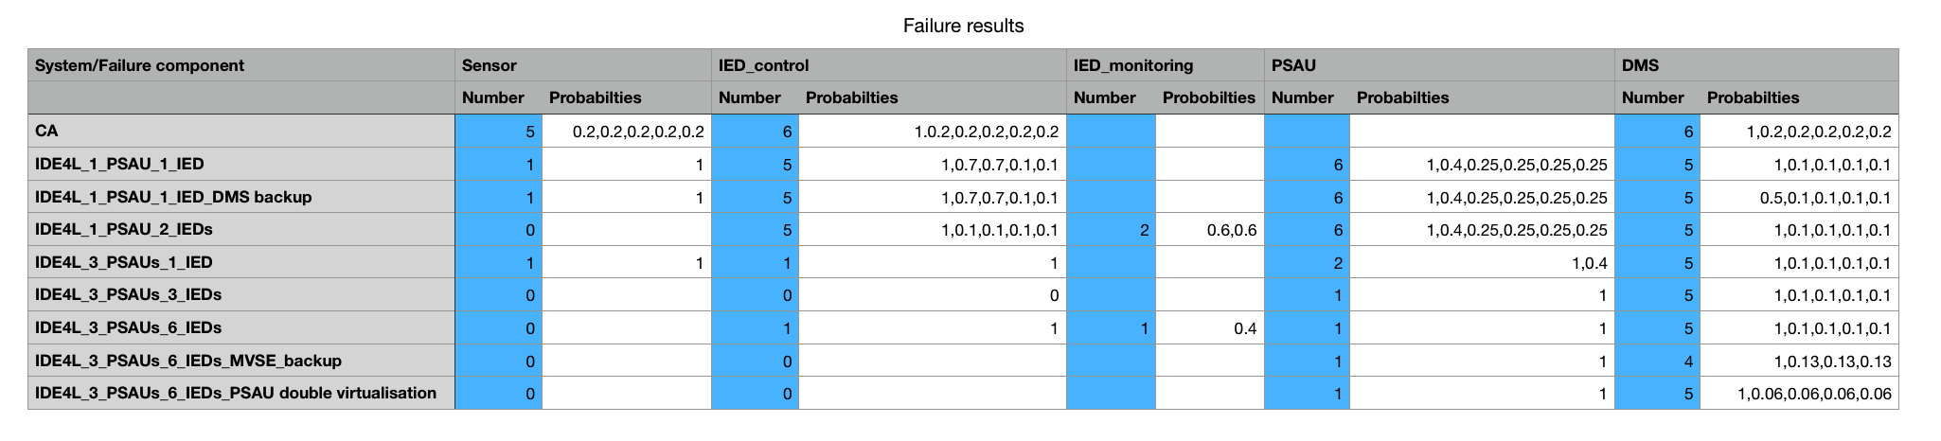

Table 4:Failure results

The number of failure use cases marked by blue can easily indicate the rise in reliability.

For better comparison, we list detailed failure probability of each use case in table 5:

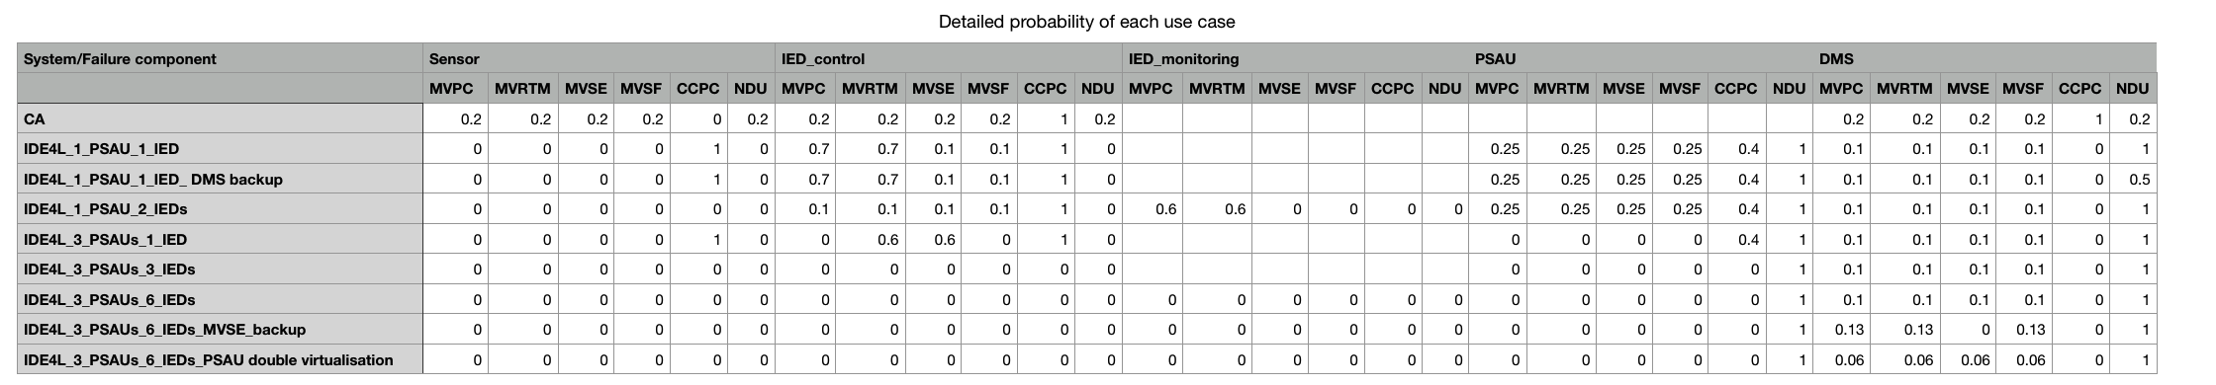

Table 5: Detailed failure probability of each use case

Above is just an intuitive impression of all the data we can achieve from GSPN analysis function, following we will present detailed comparative analysis corresponding to the specific model.

For each sensor, IED, PSAU and DMS, there are three common ways for destroying the components: communication link failure, device physically breakdown and data corruption, which are separately denoted by transitions TCLF, TDC and TDPB. PSAU has a particular cause of failure：database hacked denoted by TDH.When the component is compromised, meaning that there is a token moves from input places Psensor_on , PIED_on, PPSAU_on or PDMS_on to Psensor_down , PIED_down, PPSAU_down or PDMS_down. The firing rates of TCLF, TDC , TDPB and TDH are 1, 2, 3, 4 noted in table 6：



Table 6:The Firing Rates of Transitions

* 1. Centralized automation vs. IDE4L

For simplicity, in this section, we first assume one substation network equipped with only one sensor, one IED, one PSAU and one DMS server to demonstrate the dependability evaluation procedures. Then discuss some approaches to improve the distribution automation system dependability.

We first set up the frame (Fig.25) between Sensor, IED, PSAU and DMS in IDE4L architecture (circled by red boxes in Fig.24)

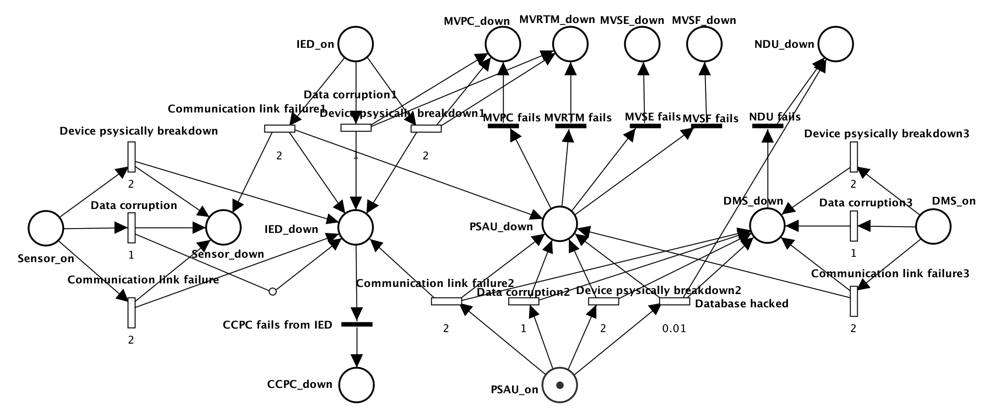

Fig.25 IDE4L architecture STPN

In order to achieve the comparison, we also model the centralized architecture using STPN (Fig.26):

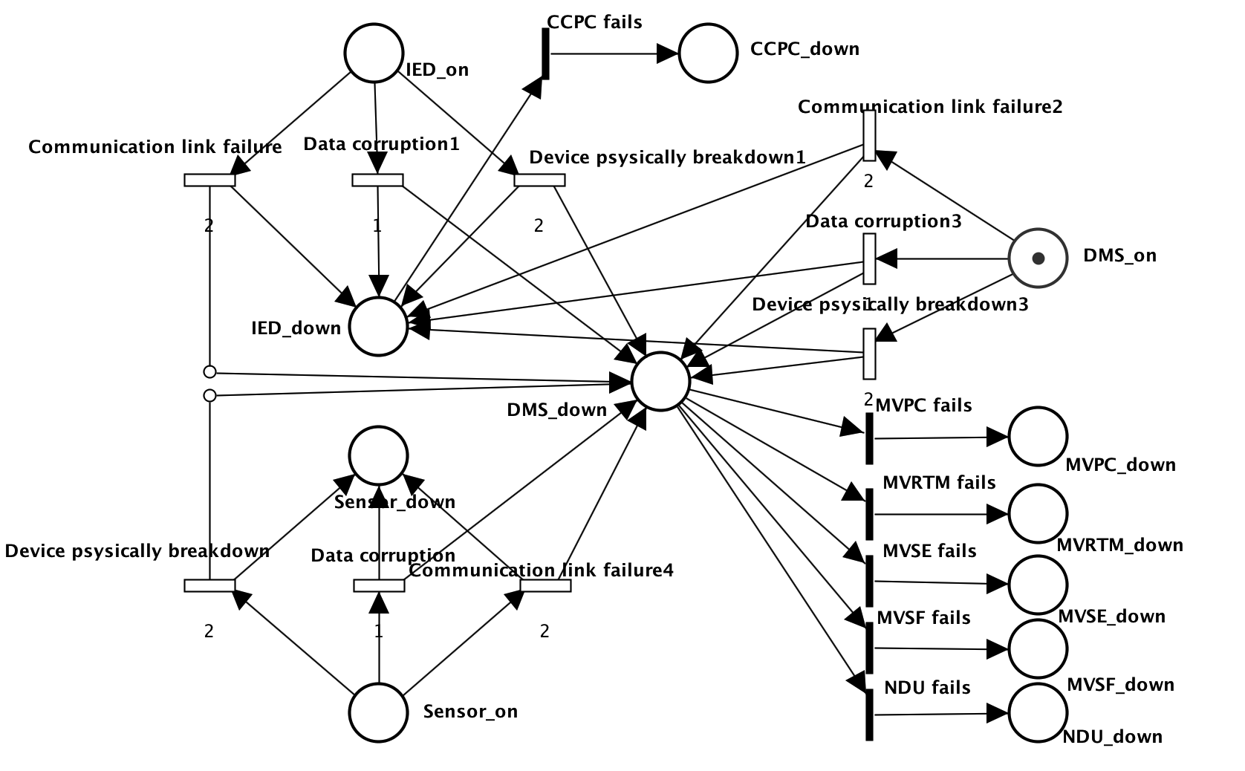

Fig.26 Centralized automation (CA) architecture STPN

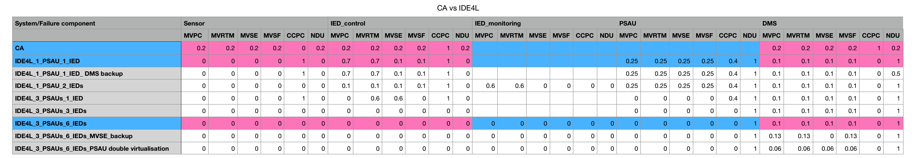

Table 7: CA vs. IDE4L

In table 7, the cell with red background is the different data,we can clearly find IDE4L significantly improve the reliability of most use cases. When sensor fails, the failure probability of MVPC, MVSE, MVRTM, MVSF and NDU decrease from 0.2 to 0 while when DMS fails, failure probability MVPC,MVSE,MVRTM,MVSF decrease from 0.2 to 0.1,CCPC from 0.2 to 0.Other increasing probabilities are instant, which can be avoided by the approaches mentioned later.

* 1. Approaches to improve distribution automation system dependability

1.Separate single IED into control and monitoring IEDs

One Sensor, two separated functional IEDs, one PSAU and one DMS:

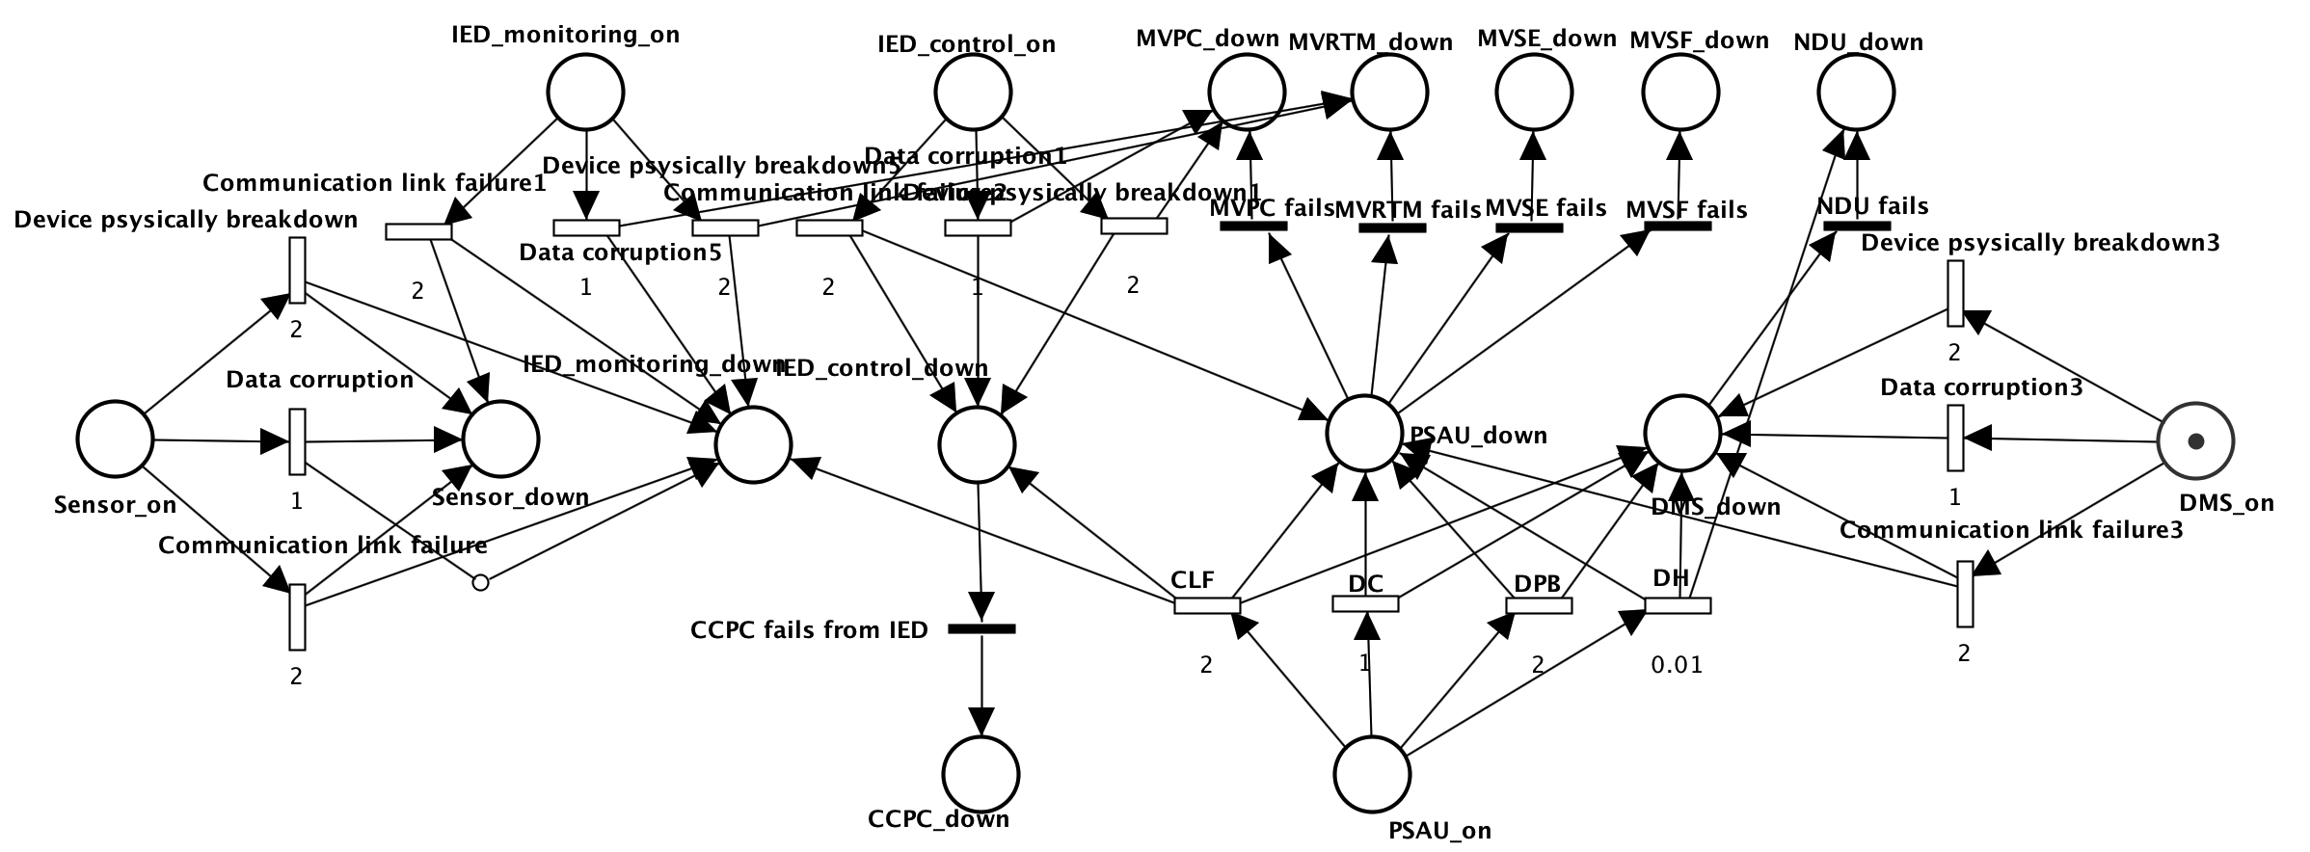

Fig.27 Separate single IED into control and monitoring IEDs

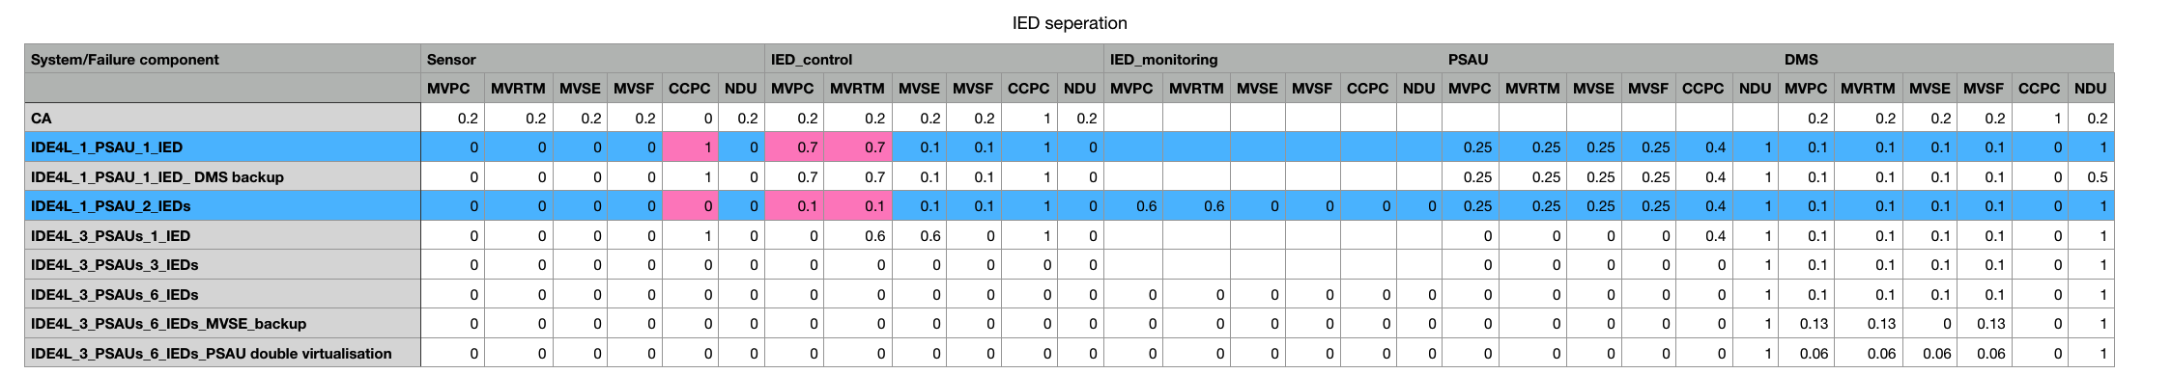

Table 8: IED separation

From Table 8, the CCPC in case of sensor failure decreases from 1 to 0, while MVPC and MVRTM in case of IED failure decrease from 0.7 to 0.1.

2.PSAU migration

One Sensor, one IEDs, three PSAUs and one DMS:

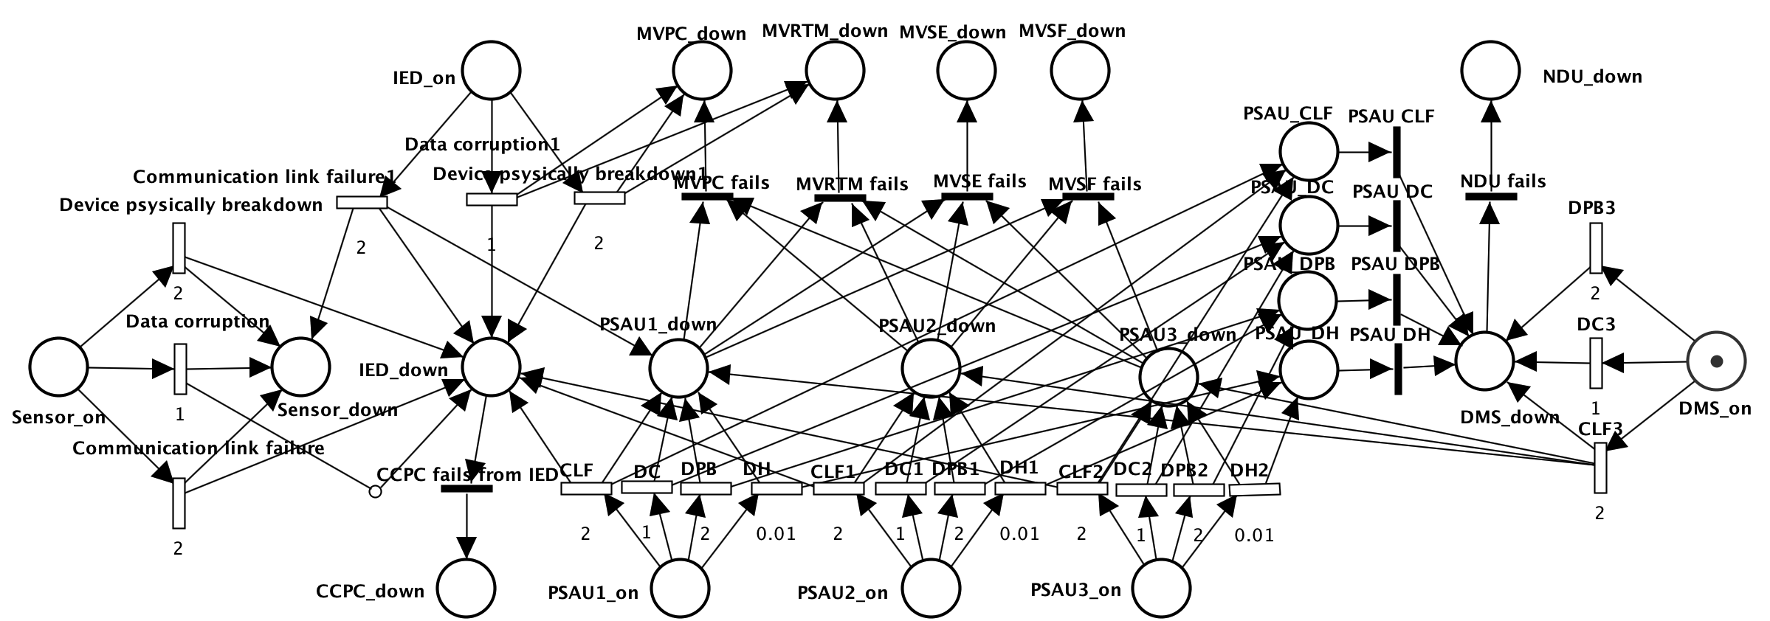

Fig.28 PSAU migration

Or One Sensor, three IEDs, three PSAUs and one DMS:

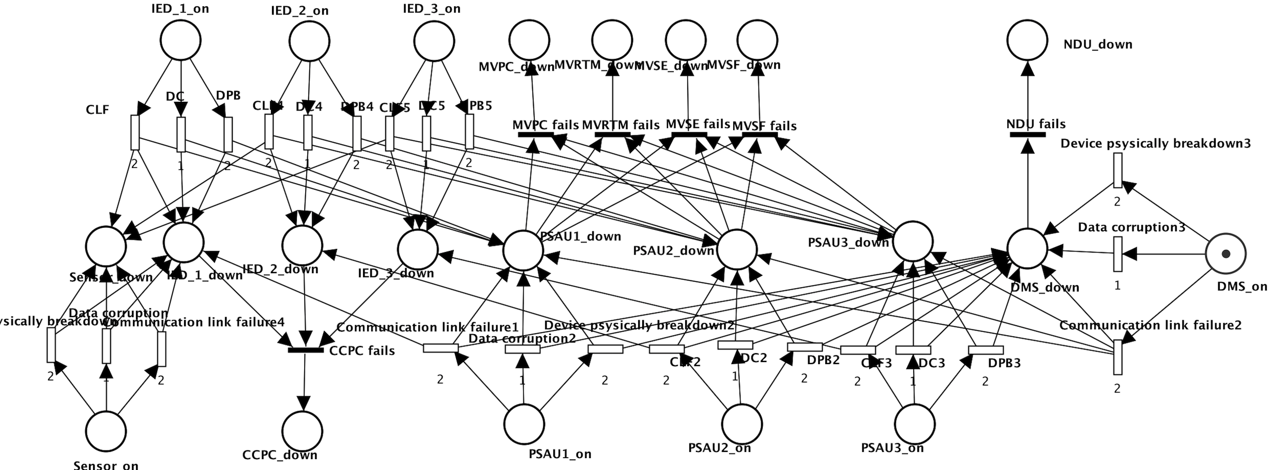

Fig.29 PSAU migration

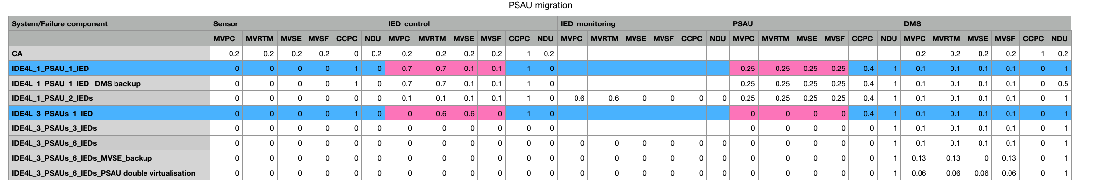

Table 9: PSAU migration

From Table 9, PSAU migration can completely eliminate the risks from IED and PSAU failures. So it is considered the most powerful protection approach, which is suitable for most cases.

For better comparison, we combine approach 1 and 2 together:

One Sensor, six separated functional IEDs, three PSAUs and one DMS:

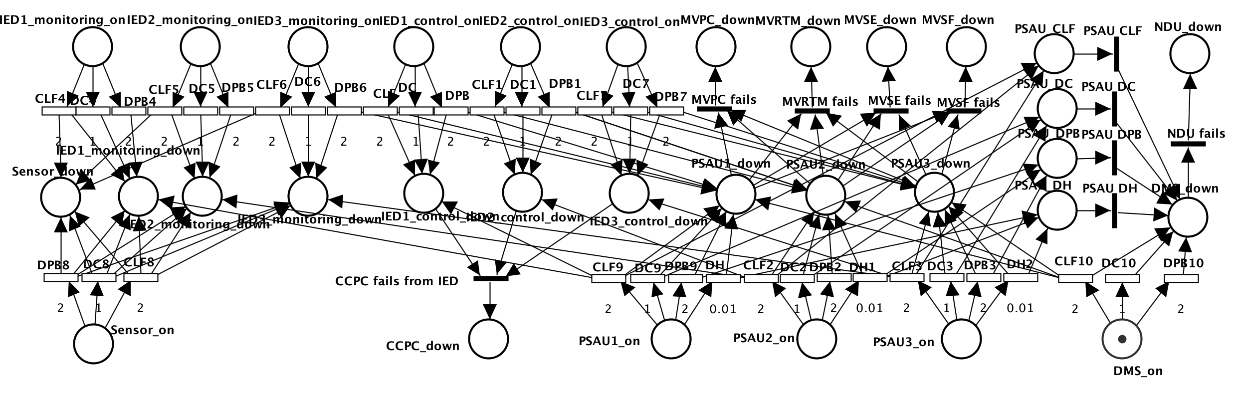

Fig.30 Separate single IED into control and monitoring IEDs while PSAU migration

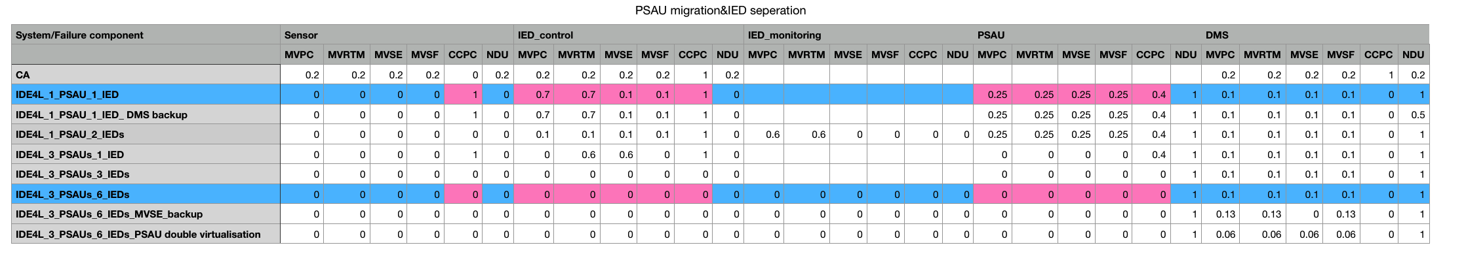

Table 10: Separate single IED into control and monitoring IEDs while PSAU migration

3.DMS backup-strategy

One Sensor, one IED, one PSAU and one DMS with Backup strategy:

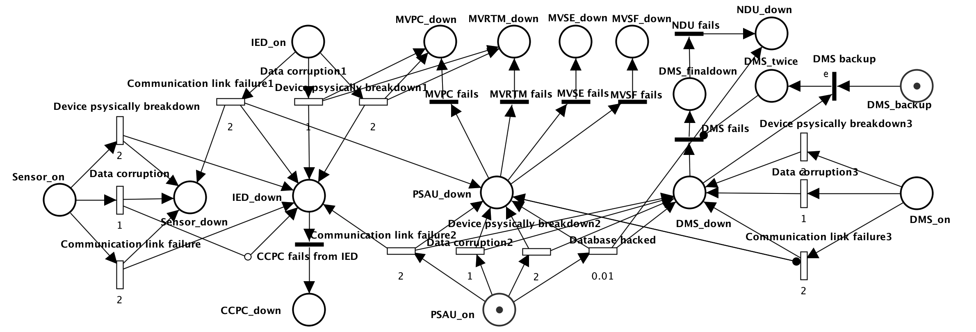

Fig.31 DMS backup-strategy

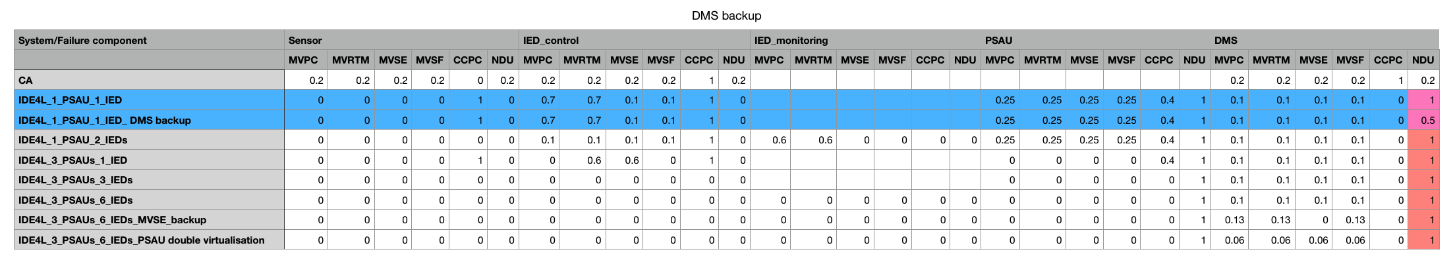

Table 11: DMS backup-strategy

From Table11, DMS backup-strategy is targeted for NDU in case of DMS failure (from 1 to 0.5).It is worth noting that in all the protective measures, only it can reduce the risk of NDU failure.

4.Bad/Missing data detection/correction

One Sensor, six separated functional IEDs, three PSAUs and one DMS with Bad/Missing data detection/correction：

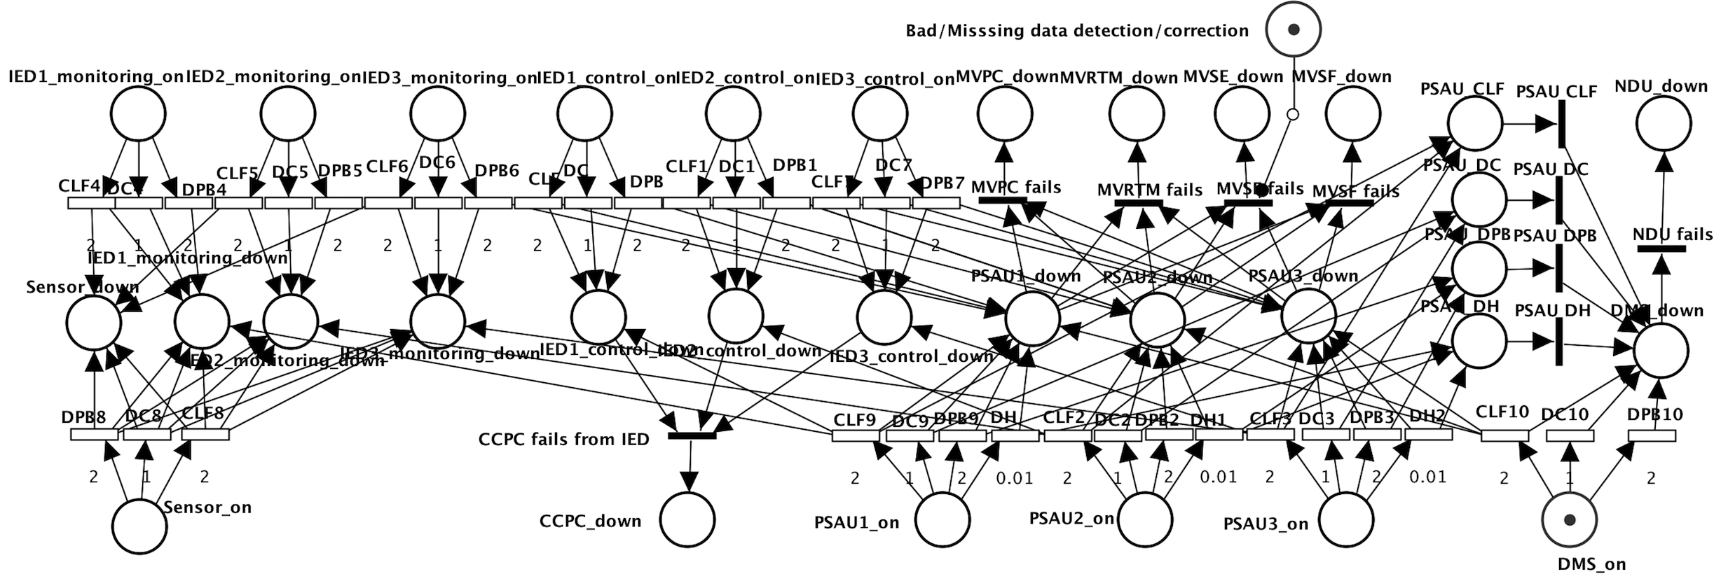

Fig.32 Bad/Missing data detection/correction

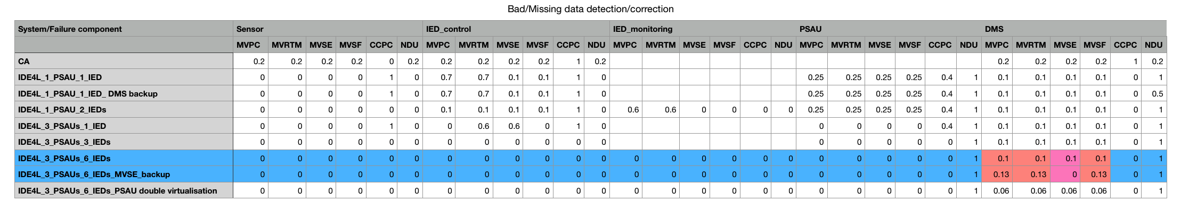

Table 12: Bad/Missing data detection/correction

From Table 12,Bad/Missing data detection/correction decreases the failure probability of MVSE in case of DMS failure from 0.1 to 0. But the cost is to slightly reduce the reliability of several other use cases

5.PSAU backup-strategy

One Sensor, six separated functional IEDs, three PSAUs and one DMS with PSAU backup strategy：

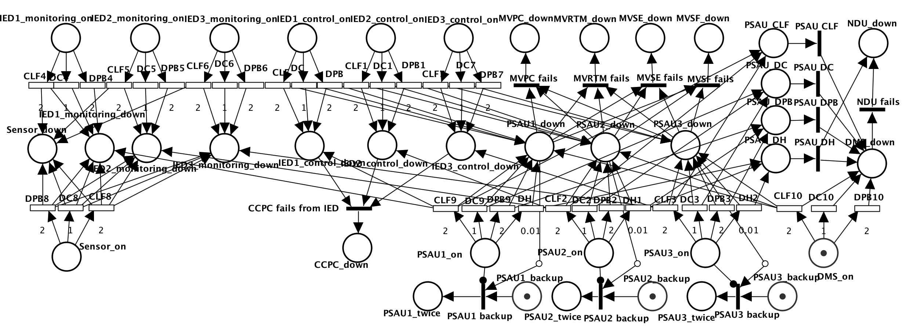

Fig.33 PSAU backup-strategy

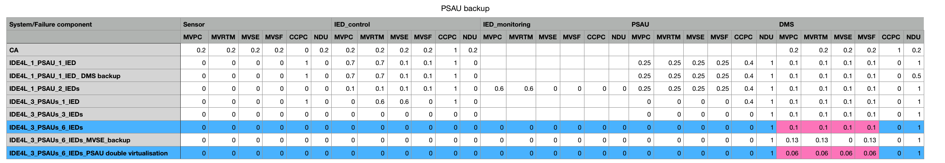

Table 13: PSAU backup-strategy

From Table 13，PSAU backup can effectively slightly decrease risks of MVPC, MVRTM, MVSE, MVSF (from 0.1 to 0.06) in case of DMS failure.

* 1. Summary

1. The functional distinction on IED can significantly improve the reliability of sensor, especially for the CCPC. But the PSAU migration can also play the same role.

2. PSAU migration is the most effective means of protection; with a strong protective effect all use cases of IED and PSAU.

3.DMS backup strategy is most targeted, for the protection of DMS，especially irreplaceable for NDU.

4.PSAU backup can effectively slightly decrease risks of MVPC, MVRTM, MVSE, MVSF in case of DMS failure.

5.Bad/Missing data detection/correction mainly protects MVSE.

1. Conclusions

This thesis is a feasibility study on using Petri Net theory for modeling and analyzing the distribution automation system, taking petri net as the toolkit, IDE4L system as the research objective, completing an investigation on the modeling of the distribution automation system. The main idea of present thesis is to employ different types of Petri Nets (SCPN, STPN) with different tools (PIPE, ORIS) in different layers (function layer, component layer) for performance analysis (survivability, dependability) of different distribution automation systems(Centralized Automation vs. IDE4L) with different protection approaches in Medium Voltage level(PSAU).Through logical reasoning and mathematical derivation can we find the most important and most vulnerable components. The feasibility and correctness of the proposed method are also illustrated by a detailed study of the 6 major use cases in MV level. The reliability and availability analysis of several different architectures verify the advantages and necessity of the IDE4L system.

The future work can focus on better protection methods for the core components, such as detailed backup strategies and further exploration for other architectures. To simplify the large system petri net and avoid the state space explosion problem that may occur in the calculation process, an optimization solution for calculation is also a hot point.

1. Bibliography

[1] Riccobono, Antonino, et al. "Systematic method for the development of future active distribution network automation architectures." *PowerTech, 2015 IEEE Eindhoven*. IEEE, 2015.

[2] Angioni, Andrea, et al. "Design and Implementation of a Substation Automation Unit." *IEEE Transactions on Power Delivery* 32.2 (2017): 1133-1142.

[3] http://www.acs.eonerc.rwth-aachen.de/cms/E-ON-ERCACS/Forschung/Forschungsprojekte/Gruppe-Power-System-Automation/~fbew/IDE4L-Ideales-Stromnetz-fuer-Alle/lidx/1/

[4] Repo, Sami, et al. "The IDE4L Project: Defining, Designing, and Demonstrating the Ideal Grid for All." *IEEE Power and Energy Magazine* 15.3 (2017): 41-51.

[5] http://ide4l.eu/results/ Deliverable 3.1: Distribution Automation Concept

[6] Murata, Tadao. "Petri nets: Properties, analysis and applications." *Proceedings of the IEEE* 77.4 (1989): 541-580.

[7]Bonet, Pere, et al. "PIPE v2. 5: A Petri net tool for performance modelling." *Proc. 23rd Latin American Conference on Informatics (CLEI 2007)*. 2007.

[8] http://www2.tu-ilmenau.de/sse_file/timenet/

[9] http://www.oris-tool.org/

[10] Zeng, Rongfei, et al. "Dependability analysis of control center networks in smart grid using stochastic petri nets." *IEEE Transactions on Parallel and Distributed Systems* 23.9 (2012): 1721-1730.

[11] <http://ide4l.eu/results/> Detailed use cases

[12] K. Molly, “On the Integration of Delay and Throughput Measures in Distributed Processing Models,” PhD dissertation, Univ. of Califormia, 1981.

[13] R. Zeng, Y. Jiang, C. Lin, X. Chu, and F. Liu, “Performance Analysis of Data Management in Sensor Data Storage via Stochasitc Petri Nets,” Proc. IEEE Global Telecomm. Conf. (Globe- com), pp. 1-5, 2010.

1. Appendix